Dataflow and Serverless for Apache Spark

Dataflow
Dataflow is built on Apache Beam, an open-source unified programming model; therefore, having a solid understanding of Beam fundamentals is crucial for effective pipeline design. Watch the following video for a quick overview of Apache Beam basics and primitives.
Click the play button to watch the video.

Transcript
At the heart of every robust Dataflow pipeline lies a deep understanding of its foundational elements. Understanding these core concepts isn't just academic; it's essential for you to build, optimize, or even troubleshoot the complex data processing workflows that will drive critical business insights. From the fundamental representation of your data and the powerful transforms that manipulate it, to the overarching pipeline that orchestrates the entire flow, the following terms are key.
Click each button to expand the 3 items and learn more.

PCollections (Parallel Collections)
These represent distributed datasets that your pipeline operates on. A PCollection is an immutable, distributed collection of elements, basically the initial large dataset before any distribution or processing begins is the "collection."
In batch pipelines, you primarily deal with bounded PCollections, meaning the data has a fixed size and is available in its entirety before processing begins.
Designing involves understanding how your input data will be represented as a PCollection and how intermediate and output data will flow through them.

PTransforms
These are the operations that process or transform data within PCollections. They are the building blocks of your pipeline's logic.
Pipeline design involves selecting and composing the right transforms to achieve your desired data transformations

Pipeline
This represents the entire workflow, from data ingestion to output.
Designing the pipeline means defining the sequence of transforms that will be applied to your PCollections to achieve the desired end result.

Dataflow design principles
Effective Dataflow pipeline design incorporates several best practices to ensure optimal performance, reliability, and cost-efficiency.
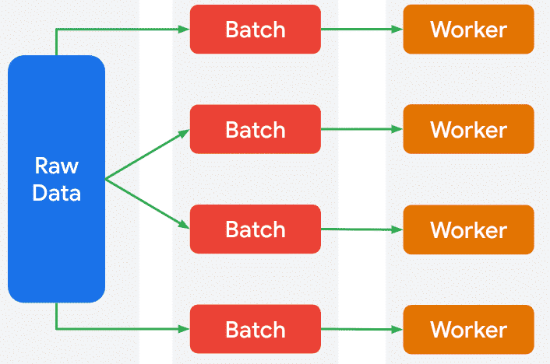
Distributed processing for batch pipelines
Scalability
- Distributed processing: Dataflow inherently supports this by distributing tasks across multiple worker nodes. As illustrated in the provided image, a large dataset is broken down into smaller chunks that are then processed in parallel by different workers. Your design should leverage this by ensuring operations can be parallelized effectively.
- Optimal batch sizing: Determine the right volume of data to process in a single Dataflow job to balance latency and efficiency.
- Data partitioning: For optimal performance, especially with grouping or joining operations, consider how data is partitioned to minimize data shuffling across the network.

Efficiently manage data in the pipeline
Efficiency and cost-optimization
- I/O optimization: Choose efficient file formats (e.g., Avro, Parquet) for input and output, especially when dealing with Cloud Storage, to reduce read/write times and storage costs.
- Native connectors: Utilize Dataflow's optimized I/O transforms (e.g., TextIO, BigQueryIO) for high-throughput interaction with Google Cloud services.
- Resource tuning: Design your pipeline to allow for appropriate worker machine types and autoscaling settings, ensuring you have enough compute resources without over-provisioning.
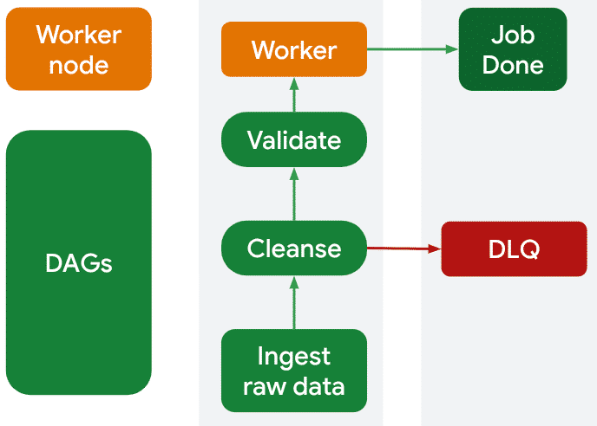
Build in fault tolerance, to continue processing valid data.
Reliability and data quality
- Schema enforcement and evolution: Plan for defining and enforcing data schemas and consider how you will handle changes to input schemas over time without breaking your pipeline.
- Error handling and dead letter queues (DLQs): Implement robust mechanisms to catch and route erroneous records to a DLQ (e.g., a Cloud Storage bucket or Pub/Sub topic) so that the main pipeline can continue processing valid data. The image from our discussion also demonstrates fault tolerance; if a "Worker" or a data chunk processing fails, the system (implied Dataflow runtime) can re-assign or retry the failed sub-task, ensuring the overall "Job Done" state is reached.

Job builder UI and Dataflow templates
Designing for maintainability and reusability involves breaking down complex transformations into smaller, modular components and leveraging Dataflow templates (both pre built and custom) for common, parameterized workflows to promote consistency and simplify deployment across your organization.
The fundamental concepts of pipeline design in Dataflow (PCollections, transforms, etc.) remain constant, regardless of the tool you use to deploy your pipeline. What changes is your level of direct interaction with these concepts and how you implement your pipeline design.
Click each flashcard to learn more.
- Click to flip
- The job builder UI simplifies pipeline deployment by letting you configure pre-existing designs via a visual interface and parameters, abstracting the underlying Beam code.
- Click to flip
- These are fully developed pipeline designs.
- Your role is to supply specific parameters (e.g., input/output paths) to customize their execution.
- Click to flip
- For custom templates, you directly design the pipeline by writing Apache Beam code, defining PCollections and applying transforms.
- You then package your design into a template for reuse, allowing others to deploy your specific workflow by providing only parameters.

How the pipeline flows
You've learned that transforms are the fundamental building blocks of any pipeline, because this is where the work of data processing and transformation occurs. In Dataflow, a key focus is on ParDo, the essential transform for applying custom, element-wise processing logic in parallel across your entire dataset.
Watch the following video to understand how to use ParDo to implement your business logic and see how multiple transforms are chained together to create a powerful and efficient batch processing workflow.
Click the play button to watch the video.

Transcript
Here's what the pipeline looks like. The first thing we'll do is read from a text file that contains the entire copy of "King Lear." After that, we'll use transforms to split each line into individual words, count the instances of each word, and output the results. Each PTransform takes a PCollection as input and sends one out as output so we can chain together the transforms.
So first things first. We can check out the input file. This is just a short snippet, but the entire book is included in the text file we'll be using. Of course, there's lots of words in this book. So let's get started counting them.
In this example, we're using Python. So the first step is to install the Apache Beam files we need. After that, we can run the word count example and specify the input and output files. Since we're not specifying a runner, the default is to use the direct runner, which runs the pipeline right on your machine. If you're just getting started or looking to debug, the direct runner is likely how you'll want to run your pipelines. After all, Beam is designed so you can run the same pipeline code on different runners.
Your local environment might be fine for "King Lear," but what if your batch data job was counting all of the words for an entire library's worth of books? In that case, we can just provide a few more options to the code and use Google Cloud Dataflow as the runner instead. The input file comes from a publicly-accessible Cloud Storage file, while the output will be a Cloud Storage bucket that I created earlier. We're also specifying to use the Dataflow runner and some other details, like which Google Cloud project this runs on. Once we run this command, the job will be created and Dataflow and start processing.
Let's take a closer look at the code. The core part of the code happens here, after the pipeline has been set up with these options that we provided. This first part of the pipeline reads the text from the input file and creates a PCollection of each line from the file. From here, we use read transform from the line's PCollection. The first transform to split the line into separate words, one transform to turn each word into a single kind of one, and another transform to group and sum all of the words and counts. The pipe operator for Beam and Python is short for applying a transformation to a collection. So with this short block of code, we're able to chain the PTransforms together by using the output PCollection of the previous transform as the input. ParDo is a transformation that takes each element from the input PCollection and performs a function on it. In this case, we have a custom regex that simply looks for groups of non-white space characters and splits each line of text into words. The final transform formats the text using a custom function and finally outputs it to the bucket. This is a fairly straightforward pipeline, so these few transforms are all we need.
While this is running, let's take a look at Dataflow in the Cloud Console. You can see the status of the job in each step of the pipeline. The name for each transform step comes from the code. You can also click on each step to see more details. Over time, the interface will update, and pretty soon, the pipeline will be complete. Beam is designed to run pipelines with parallel processing. So if you're working on a large batch or a streaming data job, the pipeline still looks the same. Thankfully, Google Cloud and Dataflow will handle all the infrastructure details for us. So with just that short bit of code, we've been able to get a count of all the words.
Now, if we take a look at the output file, we can see the count of all the words in "King Lear." However, you might notice that there are two separate counts for the word "king." That's because we didn't take capitalization to account when grouping. The easiest way to fix that would be to add another PTransform. After we split the sentence up into words, we could simply lowercase all the words and then pass that PCollection over to the group and sum transformation.
Dataflow offers an easy and intuitive way to start building pipelines quickly, even if you are not familiar with code. Now that you've got the fundamentals down, check out this quick video, How to build a data pipleline with Google Cloud
(opens in a new tab)
. The video will walk you through implementing a simple Dataflow pipeline from within the Google Cloud console, from data sources (in Cloud Storage) to transformation to landing the data in a sink (BigQuery).

Apache Spark applications
Dataproc Serverless is now Google Cloud Serverless for Apache Spark. Until updated, some documents will refer to the previous name.
Just like with Dataflow, pipeline design with Serverless for Apache Spark is the comprehensive process of conceptualizing, structuring, and implementing data processing workflows to efficiently move, transform, and analyze bounded datasets using the Apache Spark framework.
It's about making strategic choices to ensure your Spark pipelines are scalable, reliable, cost-effective, and meet your business's analytical needs without managing clusters.

Apache Spark concepts
Since Serverless for Apache Spark is a fully managed service, a solid understanding of Spark's fundamental abstractions and architecture is crucial for effective pipeline design.
Click each button to expand the 4 items and learn more.

Core Abstractions
- DataFrames
- (opens in a new tab)
- : Structured data organized into named columns, similar to database tables. DataFrames simplify data manipulation with rich APIs and are highly optimized by Spark for faster job execution.
- Datasets
- (opens in a new tab)
- : An advanced abstraction, primarily for Java and Scala, combining DataFrame's structured benefits with type-safety for enhanced error prevention.

Transformations and Actions
- Transformations: Operations that create a new Spark abstraction (DataFrame, or Dataset) from an existing one. Transformations are lazy, meaning they are not executed until an action is called. Examples include map, filter, groupBy, union, join, select, where, withColumn.
- Actions: Operations that trigger the execution of the transformations and return a result to the driver program or write data to external storage. Examples include count, collect, show, write.

Execution Model
- Driver Program: The process that runs the main() function and creates the SparkContext. It coordinates distributed operations on the cluster.
- Executors: Worker processes that run tasks and store data.
- Tasks: Individual units of work performed by executors on partitions of data.
- Stages: A physical execution plan broken into sets of tasks that can run in parallel. A shuffle operation typically marks the boundary between stages.

Spark SQL
- Spark SQL
- (opens in a new tab)
- is a module for working with structured data using SQL queries, offering high performance and deep integration with Spark DataFrames.
- This is crucial for complex data transformations that can be expressed in a SQL-like syntax.

Key design principles for Serverless for Apache Spark
Effective Serverless for Apache Spark pipeline design incorporates several best practices to ensure optimal performance, reliability, and cost-efficiency, leveraging Spark's capabilities in a managed environment.
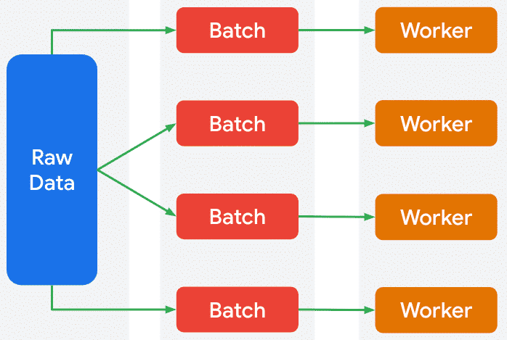
Distributed processing for batch pipelines
Scalability
- Distributed processing: Serverless for Apache Spark natively supports this by automatically provisioning and managing Spark clusters.
- Data partitioning: Design your data storage (e.g., in Cloud Storage, BigQuery) with partitioning strategies (e.g., by date, region) to enable efficient data pruning, minimize reads, and avoid data skew.
Click to zoom the image.

Efficiently manage data in the pipeline
Efficiency and cost-optimization
- I/O optimization: Use columnar/compressed formats (e.g., Parquet, Avro) for input/output to reduce overhead and costs, especially with Cloud Storage.
- Optimized connectors: Leverage high-performance, native Spark connectors for Google Cloud services for efficient data movement.
- Resource tuning: Configure Spark properties (e.g., executor memory, cores) within job submissions to fine-tune resource utilization.
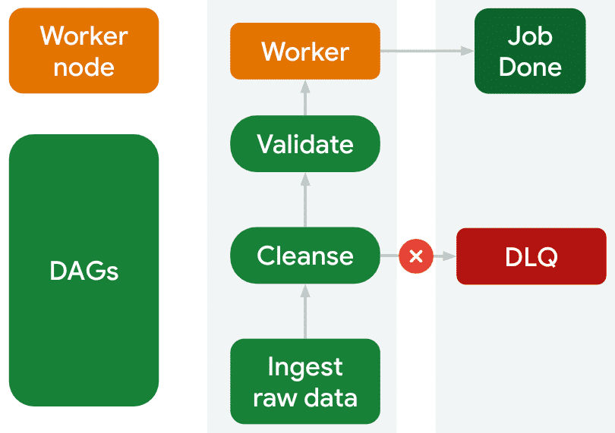
Build in fault tolerance, to continue processing valid data.
Reliability and data quality
- Schema enforcement and evolution: Spark DataFrames enforce schemas. Design pipelines to gracefully handle schema changes in input data.
- Error handling and dead letter queues (DLQs): Implement robust mechanisms in Spark code to route erroneous records to a DLQ (e.g., Cloud Storage, Pub/Sub) for inspection and reprocessing, ensuring main pipeline continuity.

Modularity and reusable pipeline design
Building robust data pipelines often involves common tasks that can be standardized and reused. This approach enhances consistency, reduces development time, and simplifies ongoing maintenance.
Click each tab to learn more.
Serverless for Apache Spark (Dataproc) Templates
Parameterized Spark Applications
Modular Spark Applications
These are pre packaged Spark applications (often a JAR for Scala/Java or a Python file for PySpark) that have defined parameters. Once created, these templates can be shared and run by anyone with the necessary permissions, simply by specifying the parameter values. This is ideal for:
- Standardizing workflows: Ensuring all teams use the same validated logic for common tasks.
- Simplifying operations: Non-developers can launch complex Spark jobs without needing to understand the underlying code or Spark intricacies.
- Accelerating development: Quickly deploy new pipelines by reusing existing, tested templates.

Design in practice
Serverless for Apache Spark abstracts away the complexities of cluster management, allowing you to focus purely on your Spark application logic.
Click each flashcard to learn how pipeline design principles apply.
- Click to flip
- Serverless for Apache Spark manages infrastructure, so you focus on writing efficient Spark code for data transformation, rather than cluster management.
- Click to flip
- Jobs are submitted directly, eliminating cluster setup.
- Serverless for Apache Spark automatically scales compute resources based on job needs and Spark configurations.
- Click to flip
- You define job submission scripts to include your Spark application files and fine-tune performance via Spark configurations.

Choose the "right" data processing engine
Welcome to "The Deep Dive," a podcast that unpacks key ideas related to batch data pipelines! In this episode, you'll hear about a crucial decision for anyone in data: choosing the right engine for your batch data.
Click the play button to listen to the audio clip.

Transcript

Google Cloud data processing engines
The table below, outlines the key distinctions between Dataflow and Serverless for Apache Spark, crucial for making informed architectural decisions for data processing at your organization.
Feature | Dataflow | Serverless for Apache Spark
Core Abstraction | Unified programming model (Apache Beam SDK) for batch and streaming; defines pipelines as transformation DAGs. | Managed environment for native Apache Spark applications; supports standard Spark APIs.
Primary Use Case | Scalable, cloud-native pipelines; ideal for complex ETL, new robust data solutions, and real-time streaming. | Migrating existing Spark/Hadoop workloads; strong for data science/ML workflows relying on Spark's libraries.
Operational Model | Fully serverless and automated; manages all worker resources, auto-scaling, and rebalancing. | Handles on-demand provisioning, management, and scaling of Spark clusters.
Engineer Experience | Works with Apache Beam SDK; focuses on pipeline logic; monitoring via Dataflow UI and Cloud Logging/Monitoring. | Leverages existing Spark expertise; monitoring via Spark History Server UI and Cloud Logging/Monitoring.
Ultimately, your choice will be based on weighing:
- 1
- Existing team expertise.
- 2
- The volume and complexity of data transformations.
- 3
- Whether the focus is on new cloud-native solutions or migrating existing workloads.

Next up: Hands on practice
Coming up next, you'll get hands-on practice applying what you've learned by building a simple Dataflow batch pipeline using the Apache Beam SDK for Python.
This is your chance to gain real-world experience as you implement pipeline filtering and then execute your code both locally and on the managed Dataflow service on Google Cloud.

